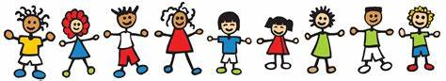
With the exception of the first few personal items on the list, we will collect all items, store them, and they will be community materials, used as needed by all the children throughout the year. Please do not label the community materials with your child’s name.
Supply donations for Art class:
- Small water color set
- Scotch permanent glue sticks
- 3 black Sharpies or fine point permanent markers
- Colored pencils
- Disinfecting wipes
- White card stock
- 5X8 Sketch Book
- Crayola colored markers

$25.00 donation for supplies for all specialists, technology software, class projects, and STEM/STEAM Science materials.
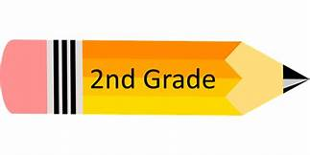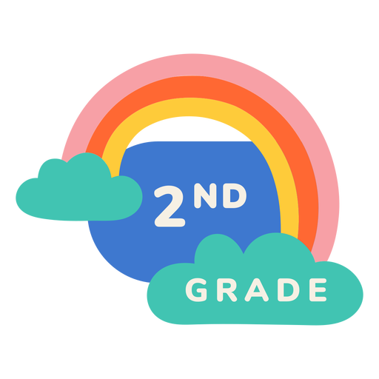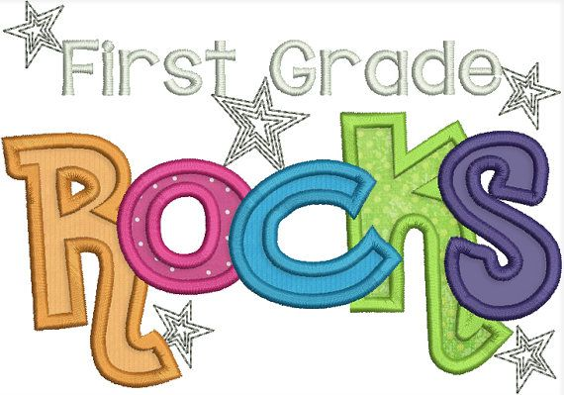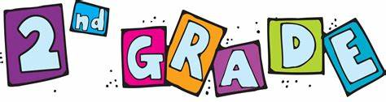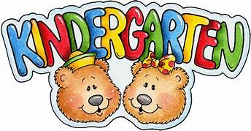
Personal Supplies
Please keep these separate from the supplies you bring to the teacher and label them with your child’s name.

- (1) standard-sized backpack (no mini-backpacks, no wheels)
- (1) pair of Fiskar Scissors
- (1) box of #2 pencils (no Roseart brand)
- (1) box Crayola brand crayons (24-count)
- (4) composition books (hard cover 9 ¾ X 7 ½”)
wide ruled (no spiral)
- Headphone or earbuds
- (1) two pocket folder (plain color)
- (1) personal pencil box
Community Materials
(These will be shared and used as needed throughout the year)

- (1) container of baby wipes
- (1) box of #2 pencils (no Roseart brand)
- (1) box of Kleenex
- (1) pack of dry erase markers
- (1) box Ziploc gallon sized bags or (1) box of Ziploc sandwich sized bags
- (12) glue sticks
- (3) large pink erasers
- (2) reams of copy paper
- Optional: paper towels, one ream of card stock (astro bright)

