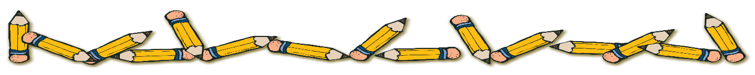
With the exception of the first few personal items on the list, we will collect all items, store them, and they will be community materials, used as needed by all the children throughout the year. Please do not label the community materials with your child’s name.
Personal Supplies
Please keep these separate from the supplies you bring to the teacher and label them with your child’s name.

- (1) standard-sized backpack (no mini-backpacks, no wheels)
- (1) box Crayola brand crayons (24-count) OR
- (1) pack of colored pencils
- (4) wide-ruled composition books (hardcover 100 page)
- (2) plastic pocket folder
- (1) headphones or earbuds (compact)
- (1) scissor
- (1) ruler
- (1) computer mouse if wanted for chromebook
Community Materials
(These will be shared and used as needed throughout the year)

- (1) container of disinfecting wipes
- (12) glue sticks
- (1) box of #2 pencils
- (3) large pink erasers
- (4) highlighters (yellow, green, blue, pink)
- (1) pack of dry erase markers
- (1) package of wide-ruled notebook paper
- (2) boxes of Kleenex
- (1) box Ziploc gallon sized bags or (1) box of Ziploc sandwich sized bags
- (2) reams of copy paper
- Optional: paper towels, one ream of colored paper

$25.00 donation for supplies for all specialists, technology software, class projects, and STEM/STEAM Science materials.
Supply donations for Art class:
- Small water color set
- Scotch permanent glue sticks
- 3 black Sharpies or fine point permanent markers
- Colored pencils
- Disinfecting wipes
- White card stock
- 5X8 Sketch Book
- Crayola colored markers

