With the exception of the first few personal items on the list, we will collect all items, store them, and they will be community materials, used as needed by all the children throughout the year. Please do not label the community materials with your child’s name.
$25.00 donation for supplies for all specialists, technology software, class projects, and STEM/STEAM Science materials.
Supply donations for Art class:
- Small water color set
- Scotch permanent glue sticks
- 3 black Sharpies or fine point permanent markers
- Colored pencils
- Disinfecting wipes
- White card stock
- 5X8 Sketch Book
- Crayola colored markers

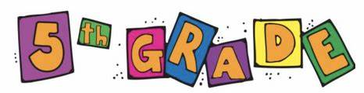
Personal Supplies
Please keep these separate from the supplies you bring to the teacher and label them with your child’s name.

- (1) standard-sized backpack (no mini-backpacks, no wheels)
- (1) pair of Intermediate Scissors
- Ear buds or headphones for Chromebooks
- (1) box of colored pencils
- (5) spiral bound plain colored notebooks
- (5) pocket folders
- (3) large glue sticks
- (2) black Sharpie permanent markers
- (1) red pen
- (1) soft pencil pouch (no box)
- (2) highlighters

Community Materials
(These will be shared and used as needed throughout the year)

- (2) containers of disinfecting wipes
- (2) boxes of Kleenex
- (2) pack of index cards (any size)
- (2) pack of post-it notes (small or medium)
- (1) ream of copy paper
- Optional: paper towels, one ream of card stock
- (3) dozen of #2 pencils
- (4) black dry erase markers (chisel tip)

