With the exception of the first few personal items on the list, we will collect all items, store them, and they will be community materials, used as needed by all the children throughout the year. Please do not label the community materials with your child’s name.
$25.00 donation for supplies for all specialists, technology software, class projects, and STEM/STEAM Science materials.
Supply donations for Art class:
- Small water color set
- Scotch permanent glue sticks
- 3 black Sharpies or fine point permanent markers
- Colored pencils
- Disinfecting wipes
- White card stock
- 5X8 Sketch Book
- Crayola colored markers

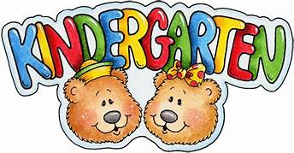
Personal Supplies
Please keep these separate from the supplies you bring to the teacher and label them with your child’s name.

- (1) standard-sized backpack (no mini-backpacks, no wheels)
- (1) pair of Fiskar Scissors
- Over the head earphones
- (1) box Crayola brand crayons (24-count)
- (1) primary composition book with picture space
- (6) glue sticks
- (1) Prang water color (8 count)
- (1) black and white composition books (hardcover 9 ¾” X 7 ½”)

Community Materials
(These will be shared and used as needed throughout the year)

- (2) boxes Crayola brand crayons (24-count)
- (1) container of baby wipes
- (1) box of Kleenex
- (12) glue sticks- (2) six packs
- (1) box Ziploc gallon sized bags and (1) box of Ziploc sandwich sized bags
- (1) ream of copy paper
- (2) pack black Expo Brand dry erase markers (4pk)
- (1) bottle of soap (girls)
- (1) bottle of sanitizer (boys)
- (1) pack of pink erasers
- (1) container of disinfecting wipes
- Optional: paper towels, one ream of card stock

